1. 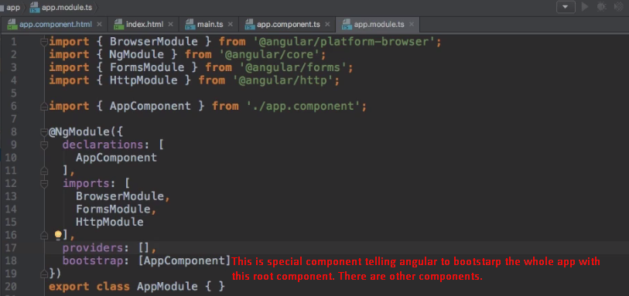
2. 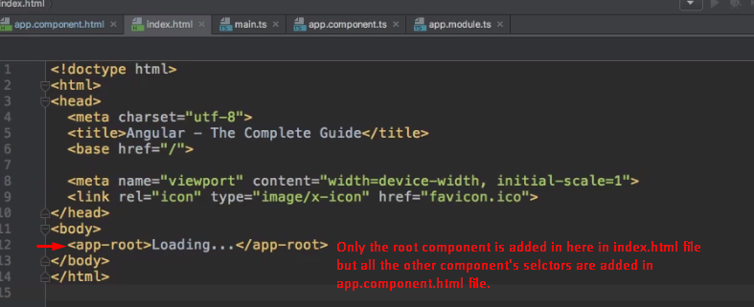
3. Let’s add a component.
4. **Requirement**: Let’s say we want to output some server information. Some other people are building back-end for our server management application and we want to output some server information.
5. 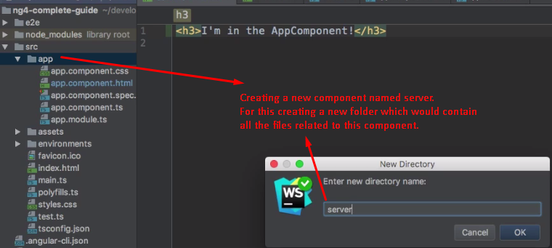  
   **NOTE**: Component name is server so folder name is also server making sense.   
   **NOTE**: There is no hard-rule to have a separate folder for each component but makes sense.

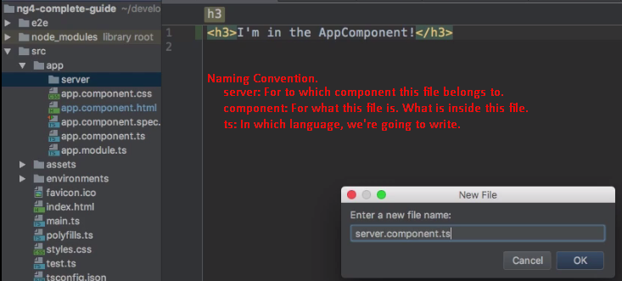

1. What is angular component?
   1. Just a class written in typescript.
   2. Angular instantiates it.
2. Export the class in the server.component.ts, as we’re going to use this class in app component. 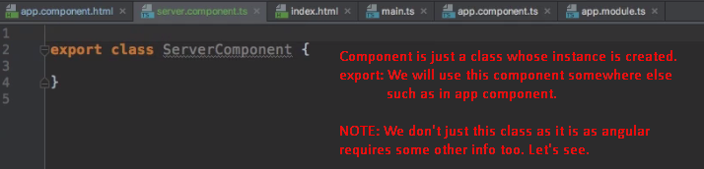  
   The other info tells angular that this is not only just simple typescript class but a special class, component. We do this by adding a special decorator. Decorators are typescript features which allow you to enhance your classes.
3. 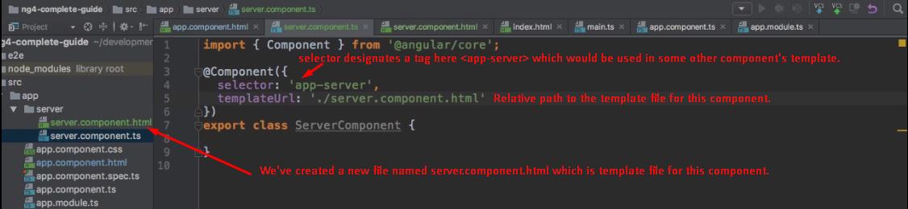
4. Let’s see how to use this component in the next lecture.
5. 